**Test Plan for VWO.com Login Page**

Table of Contents

Objective: 2

Scope: 2

Testing Scope: 2

**Inclusion:** 2

**Exclusion:** 2

Test Environments: 2

Test Strategy: 3

Test Schedule: 3

Test Deliverables: 4

Entry and Exit Criteria: 4

**Entry Criteria:** 4

**Exit Criteria:** 4

Test Cases Management: 5

Defect Reporting Procedure: 5

Risks and Mitigations: 5

Approvals: 5

# **Objective:**

In this document of the Test Plan for the VWO application, measure its impact everywhere on Login criteria with all possible scenarios.

# **Scope:**

The features and functionality of VWO.com that will be tested, such as the user interface, login functionality.

The types of testing that will be performed, such as manual testing, automated testing and accessibility testing.

The environments in which testing will be conducted such as different browsers, operating systems, and device types.

The criteria that will be used to evaluate the success of the testing, such as the number of defects found, the time taken to complete the testing and user satisfaction ratings.

The roles and responsibilities of the team members involved in the testing such as the test lead, testers, and developers.

The schedule and milestones for the testing, including the start and end dates, and the planned testing activities.

The tools and equipment that will be used for testing, such as testing software, hardware, and documentation templates.

# **Testing Scope:**

## **Inclusion:**

Below listed user story are in scope during this testing,

* Create Account
* Login

## **Exclusion:**

Below listed user story are out of scope for this testing,

* Dashboard Page
* Support Page
* Support Widget - ZOHO chat

# **Test Environments:**

Our test environment includes below configuration:

**System:** Mac OS

**Browser:** Chrome, Firefox, Safari

**Test Credentials:**

*Email:* contact+atb7x@thetestingacademy.com

*Password:* Wingify@1234

# **Test Strategy:**

**Test Approach**

1. Create a Test Scenarios and Test Cases for Login page of VWO.
2. While developing test cases, use a number of test design techniques.

* Equivalence Class Partition
* Boundary Value Analysis
* Decision Table Testing
* State Transition Testing
* Use Case Testing

1. We also use our expertise in creating Test Cases by applying the below:
   * Error Guessing
   * Exploratory Testing
   * We prioritize the Test Cases
2. Perform Smoke testing to make sure the build is stable.
3. Execute all the test cases derived in depth.
4. Regression testing will be done for the existing workflows.

**Test Case Documentation:**It is crucial to document the test cases to define the test coverage. This will help in tracking the goal and include them for quality improvement.

**Test Stages:**Majority of the tests will be run against devo/beta endpoint.

**Automation Test Coverage:**All the P0 tests are mandatory to be automated.

# **Test Schedule:**

Following is the test schedule planned for the project –

Task Time Duration

|  |  |
| --- | --- |
| **Task** | **Dates** |
| ▪ Creating Test Plan | 08/07/2024 |
| ▪ Test Case Creation | 08/07/2024 |
| ▪ Test Case Execution | 10/07/24 – 13/07/24 |
| ▪ Summary Reports Submission Date | 13/07/2024 |

*Just mentioning the sample dates.

# **Test Deliverables:**

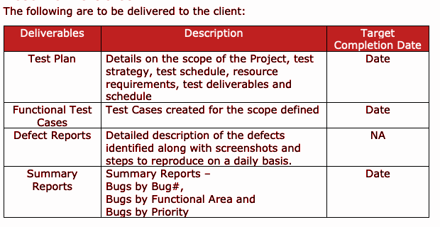

# **Entry and Exit Criteria:**

## **Entry Criteria:**

Testing will begin when the following criteria are met:

1. Test cases are reviewed and agreed upon.
2. The code has reached Beta stage.
3. All the basic use cases of all the APIs are working as expected.
4. Unit test coverage is 95%.

## **Exit Criteria:**

* 100% Requirement coverage is achieved.
* Test Coverage
  + All Tests are executed once.
  + Test Coverage is around 95%.
  + Test First Pass % is around 90%.
  + All Critical Tests are passed.
  + Failed Tests are of low priority.
  + Complete Functional Coverage is achieved.
* All Launch Blockers are fixed and Verified. No known High Sev Bugs/Issues are in Open State.
  + QA has re-tested all launch blockers and high priority bugs and closed them.
  + Corresponding Regression scenarios are successfully executed.
* Very few Low Priority bugs that are open do not impact the software usage.
* Very few Medium Priority bugs that are open should have a workaround in place.

# **Test Cases Management:**

Test cases documented in JIRA tool.

TC Link: <<Link for Test cases>>

# **Defect Reporting Procedure:**

* Defect Triage will be conducted after the test complete with the PM, SDM, SDE, QA and QAM involved.
* All issues will be reported under the folder "VWO_Test_Defects" on JIRA.

# **Risks and Mitigations:**

The following are the list of risks possible and the ways to mitigate them:

|  |  |
| --- | --- |
| **Risks** | **Mitigations** |
| Non-Availability of a Resource | Backup Resource Planning |
| Build URL is not working | Resources will work on other tasks |
| Less time for Testing | Ramp up the resources based on the Client needs dynamically |

# **Approvals:**

Team will send below list of documents for Client Approval:

• Test Plan

• Test Scenarios

• Test Cases

• Reports

Testing will only continue to the next steps once these approvals are done.